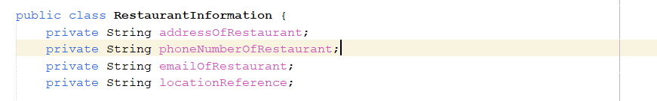

Redundant attribute names. We already know that this is a class referencing the Restaurant

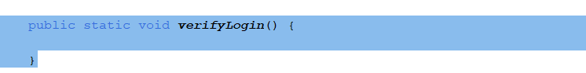

Even though it is in the UML, this method doesn’t have a body

Even though it is in the UML, this method always return an empty Menu class

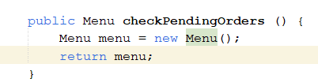



Every time you enter an Adress, it is never used, and it is instead replaced with null

Observations:

Attribute names

Simplify the names of the attributes form the RestaurantInformation class

Same for the userId attribute in the user class

A lot of methods don’t have a body, therefore doesn’t have a real functionality

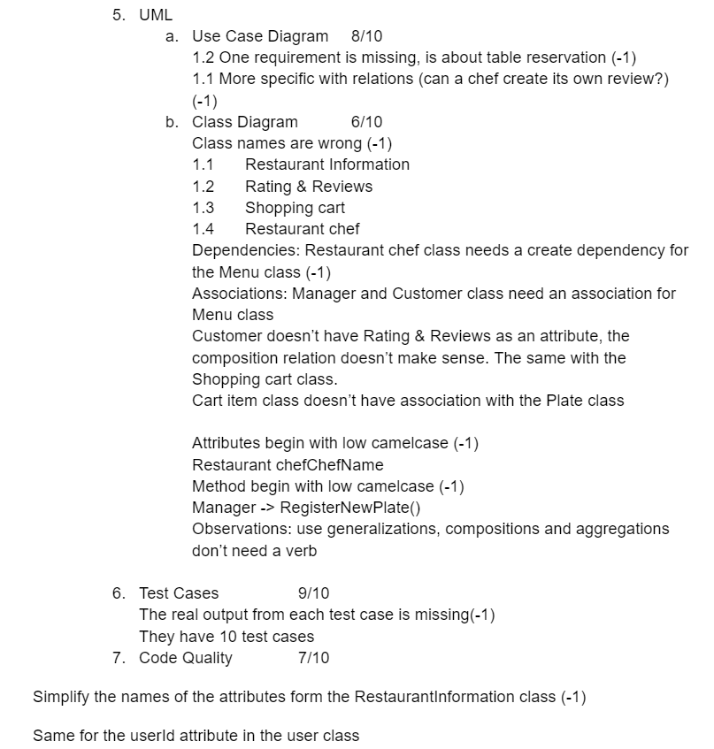The main class has too many methods on it. There is the display of the Menus, some validations, csv files management and more.